Rajith Radhakrishnan lab 3 109061463

This week’s lab is about getting used to the autoroute and fixing any design rule errors and mistakes. This lab is used as a practice for the current meter designs. After performing autoroute, the result with least vias and 100% completion are selected. After implementing, any wires that are very close to the pad are assessed and moved away to avoid any electrical shorts.

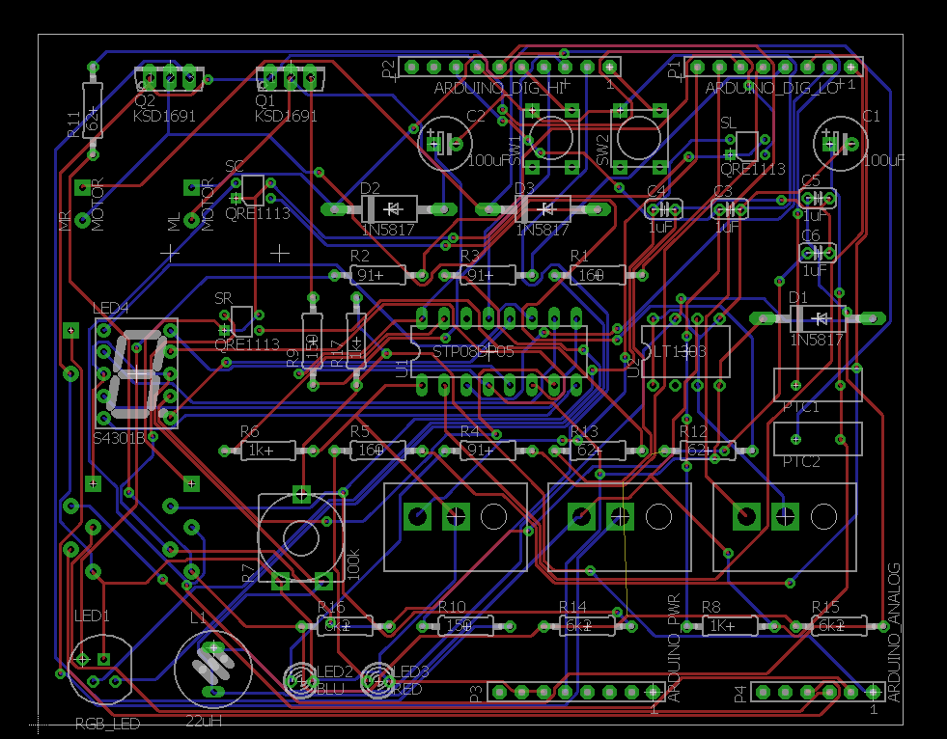

Current meter design schematic and bill of material

https://radrajith.github.io/ESE_323_PCB_Design/